SAM Junctional Tourniquet (SJT) Skill Sheet

Objective: Demonstrate the proper application of a SAM Junctional Tourniquet.
References:
TCCC Curriculum, SJT Module
Evaluation: Students will be evaluated as a Pass/Fail (P/F). The instructor will verify the student’s ability to quickly and effectively apply an SJT to a fellow student by observing the student’s procedure and technique.
Materials:
Student Checklists
SJTs
Students perform on each other
Instructor Guidelines:
- Provide each instructor with Student Checklists.
- Ensure each student has all required materials.
- Read the Learning Objective and the evaluation method to the student.
- Explain the grading of the exercise.

The SJT is comprised of four basic parts:
  - Pelvic Belt
  - Hand Pump
  - (2) Target Compression Devices (TCD) SJT 102
  - Auxiliary Strap and TCD Extender

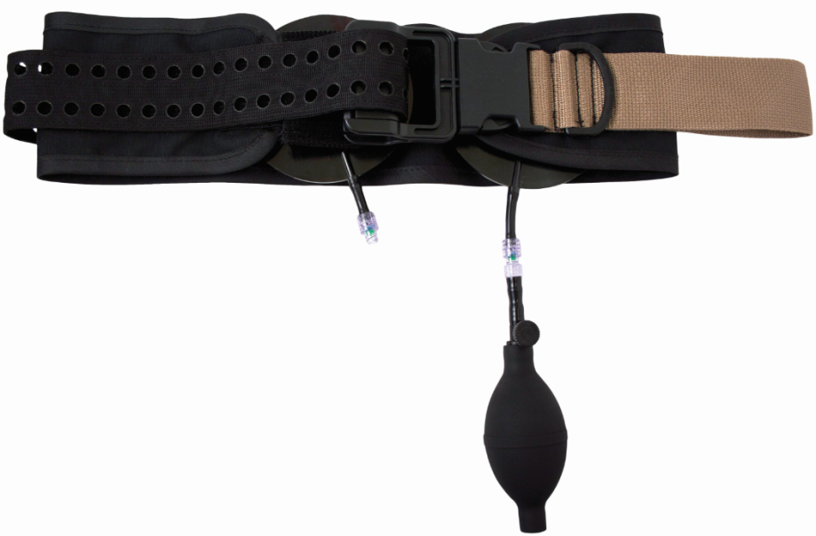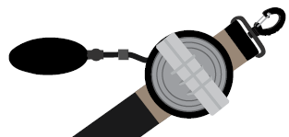

The SJT has multiple indications:

Pelvic Stabilization
Control Inguinal Hemorrhage
Control Axillary Hemorrhage

INGUINAL HEMORRHAGE

STEP 1
Determine that the injury is not amenable to treatment with a standard limb tourniquet. Remove all objects from the casualty’s pockets. Slide the belt underneath the casualty, positioning the Target Compression Device (TCD) over the area to be compressed (over the femoral pulse just below the inguinal ligament). Use sterile gauze or hemostatic dressing of targeting directly over a wound. When treating a unilateral injury and using only one TCD, the belt may be applied from either side, depending upon the location of the injury.

For bilateral application, use a second TCD.

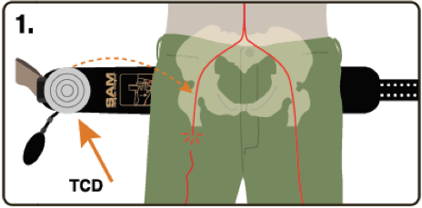

STEP 2
Hold the TCD in place and connect the belt by snapping the buckle together.

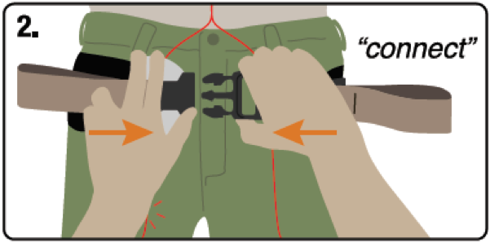

STEP 3
Pull the brown handles away from each other until the buckle secures. You will hear an audible click. Fasten excess belt in place by pressing it down on the Velcro. You may hear a second click once the belt is secure.

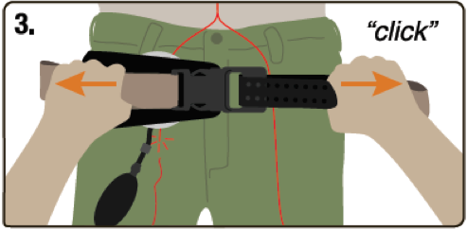

STEP 4
Use the hand pump to inflate the TCD until hemorrhage stops. In this practical exercise, the student will verbalize both inflating the TCD and checking for hemorrhage control. Monitor casualty during transport for hemorrhage control and adjust the device if necessary.

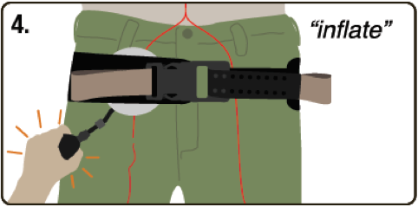

TO REMOVE, unbuckle the belt.

AXILLARY HEMORRHAGE

STEP 1

Apply the SJT to the casualty under the arms, as high as possible. Place the D-ring on the injured side, aligning it with the side of the neck. Connect the buckle and secure the strap in place by pulling the brown handles apart until you hear a click. Maintain tension and secure the loose end of the strap by pressing it down on the Velcro.

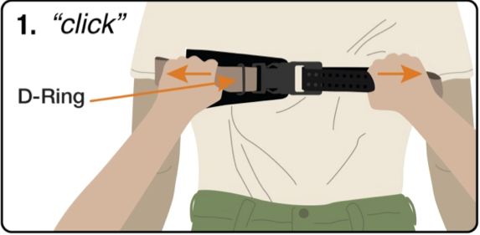

STEP 2

Attach the Extender to the TCD prior to application, and attach the TCD to the strap by pressing it onto the brown Velcro. The Extender allows for more direct pressure on the artery.

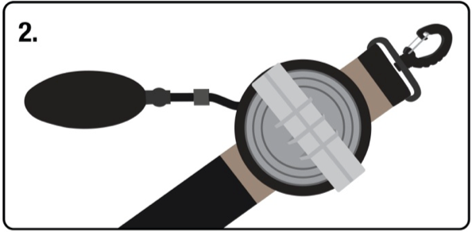

STEP 3

Attach the large clip on the strap to the D-ring on the front of the SJT.

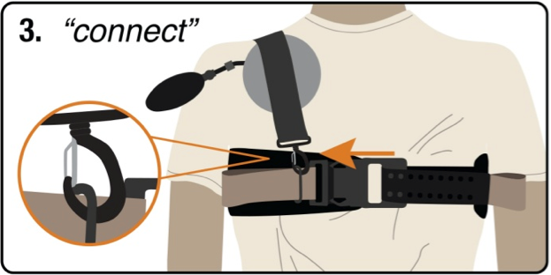

STEP 4

Connect the accessory strap to the cord on the back of the SJT using the small clip, as close as possible to the casualty’s midline.

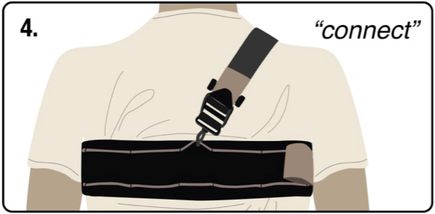

Step 5

Tighten the strap as much as possible using the brown handle. Use the hand pump to inflate the TCD until hemorrhage stops. In this practical exercise, the student will verbalize both inflating the TCD and checking for hemorrhage control. Monitor casualty during transport for hemorrhage control and adjust the device if necessary.

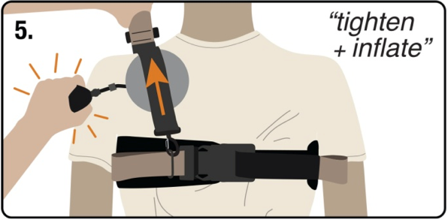

TO REMOVE, unbuckle the belt.

Considerations
- The SAM Junctional Tourniquet is intended to be left on for up to four hours.
- Remove only at a Definitive Care Facility.
- Additional inflation of the TCD may be necessary with changes in altitude.

Student Checklist
Control Bleeding Using a SAM Junctional Tourniquet

Task | Completed
 | 1st | 2nd | 3rd
Determined that the injury was not amenable to treatment with a standard limb tourniquet. | P / F | P / F | P / F
Determined if a bilateral or unilateral application was needed. | P / F | P / F | P / F
FOR INGUINAL APPLICATION
Removed items from pockets that may interfere with SJT application. | P / F | P / F | P / F
Properly placed the SJT so that TCD(s) was (were) correctly located just below the inguinal ligament(s). | P / F | P / F | P / F
Correctly tightened and secured the belt to before inflating the TCD(s). | P / F | P / F | P / F
Verbalized inflating the TCD(s) until distal bleeding stopped. | P / F | P / F | P / F
Verbalized checking for hemorrhage control. | P / F | P / F | P / F

Critical Criteria:

_____ Did not correctly position the SJT.

_____ Did not verbalize applying sufficient pressure to stop distal bleeding.

Evaluator's Comments:

Student Name: |  |  | Date:
Evaluator: |  | Pass: |  |  |  | Fail:

